ELECTRONIC PLAN OF STUDY
All degree seeking graduate students are required to submit an electronic plan of study (EPOS) as soon as possible in their program. This EPOS serves as a contract between the student, their advisory committee, and the Graduate School. It lists the courses that the student expects to take for the degree program, any concentration(s) the student is pursuing, the faculty members who will mentor them throughout their study and other key degree-related items.
The EPOS must be submitted and receive all departmental signatures prior to the first day of classes of the session of anticipated graduation. Departmental signatures include the department’s Plan of Study Coordinator, the Head of the Graduate Program (or that person’s designee), and each member of the advisory committee. The Graduate School recommends that students submit their plan at least a month in advance of the start of the session of expected graduation to ensure sufficient time for departmental review. For more information, see Section X of the University Catalog (Purdue University, 2017).

Student Instructions
Before you begin, the Graduate School recommends that you meet with your advisor to discuss aspects of your plan, such as the courses that should be included, the individual(s) who should be a part of the advisory committee, and any transfer courses or master’s credits to be used (if applicable). If you are not sure who to reach out to in the department, start with the department’s Graduate Contact. Once you have an outline of the courses and committee, follow Steps 1-12 below to begin building your EPOS.

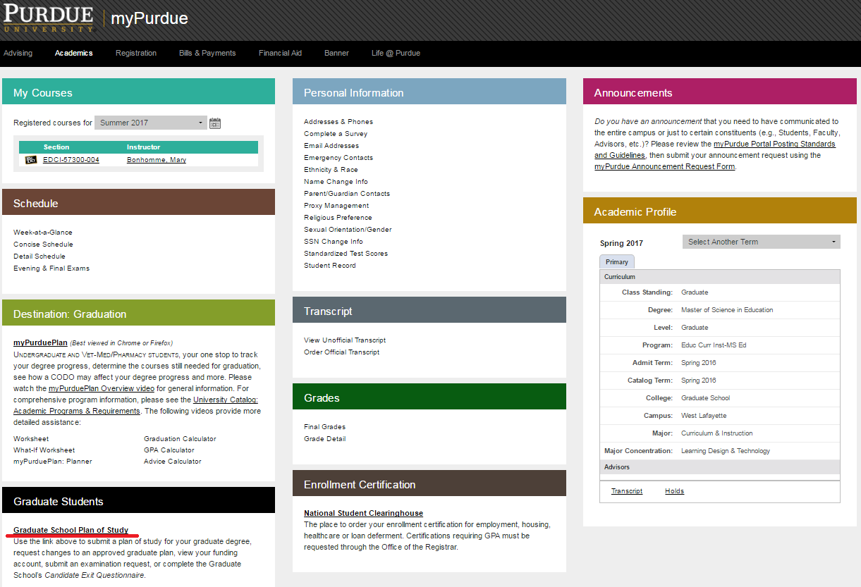
- Login to myPurdue using your Purdue career account credentials. Under the “Academics” tab, select the “Graduate School Plan of Study” link in the “Graduate Students” box.
- Login using your Purdue career account credentials. 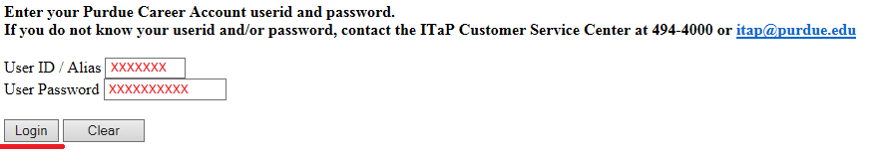
- Click the “Plan of Study Generator” link.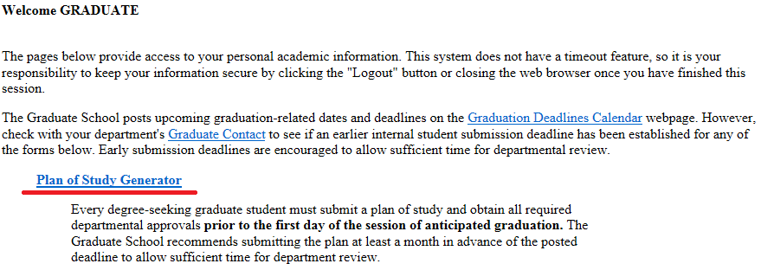
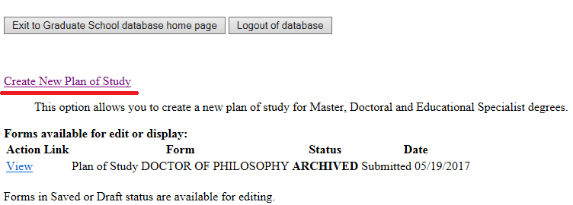
- Select “Create New Plan of Study.”

Notes on Creating a New Plan
If you have a plan in “Saved” or “Draft” status, you should see an “Edit” link to the left of that plan. Please use that link to re-access the existing form rather than begin a new plan. Only one saved or draft plan can exist in the system at a time.
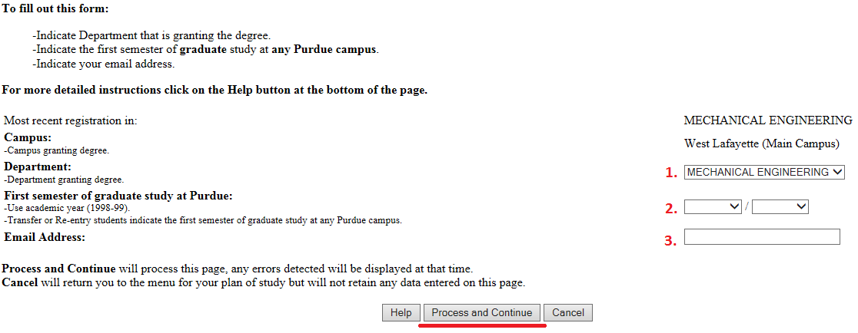
- Select the department that will be responsible for awarding this degree, choose your first session of study in this program, and enter your email address. Once all fields have been completed, select “Process and Continue.”

Explanation of Purdue’s Academic Calendar
The academic calendar at Purdue begins with the fall session. Fall 2017 should be entered as “Fall/2017-18.” Spring 2018 should be recorded as “Spring/2017-18.” Summer 2018 as “Summer/2017-18.”

Note to Interdisciplinary Students
Interdisciplinary students will see several “Department” options in the 1st drop-down box since they use the Plan of Study to declare their degree granting major. This major should match their major professor’s primary department association.
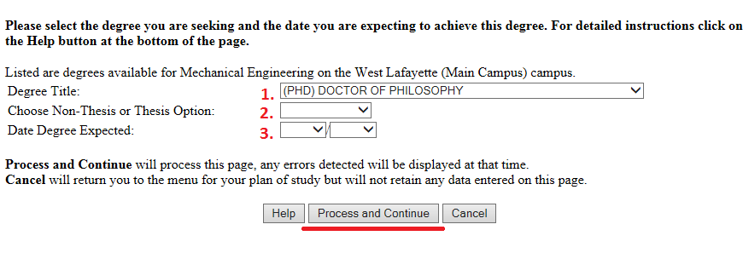
- Select the degree for which this plan is being created, specify whether this is for a thesis or non-thesis degree, and choose your estimated date of degree completion. If you are pursuing a doctoral degree, leave Step 2 blank. Once all fields have been completed, select “Process and Continue.”

“Degree Title” Field
The “Degree Title” drop-down will automatically display all degree options available within the department, regardless of your current classification.

Date Degree Expected
The date listed in the 3rd drop-down above is just an estimate. Though this date is helpful to those reviewing the form, students will not automatically be added as candidates in the session listed.
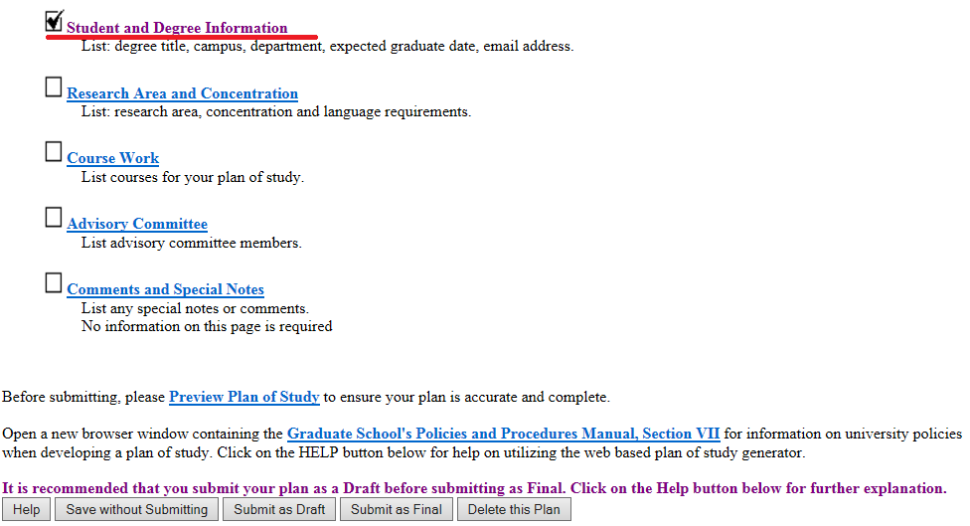
- This second “Process…” button creates the plan, and places it in “Saved” status. To adjust the information entered during Steps 5-6, select the first “Student and Degree Information” link.

Introduction to the “Home” Screen for Plans in “Saved” or “Draft” Status
- The top “Student and Degree Information” link has a “check” to the left of it indicating that all required fields in this area have been entered. “Checks” are required in at least the first four main categories in order to submit the plan.
- You can preview this plan by clicking the “Preview Plan of Study” link shown in the screenshot above. “Previewing” brings up the plan as department and Graduate School staff will see it when they are reviewing the form.
- The “Graduate School’s Policies and Procedures Manual…” link at bottom of the page will open Section VII of the manual in a new tab. This section of the manual lists the key university-wide policies governing the content of graduate plans. Keep in mind that departments may set stricter requirements in any area. If your department has set higher standards for any section of the plan, you will need to abide by the policy established by the department.
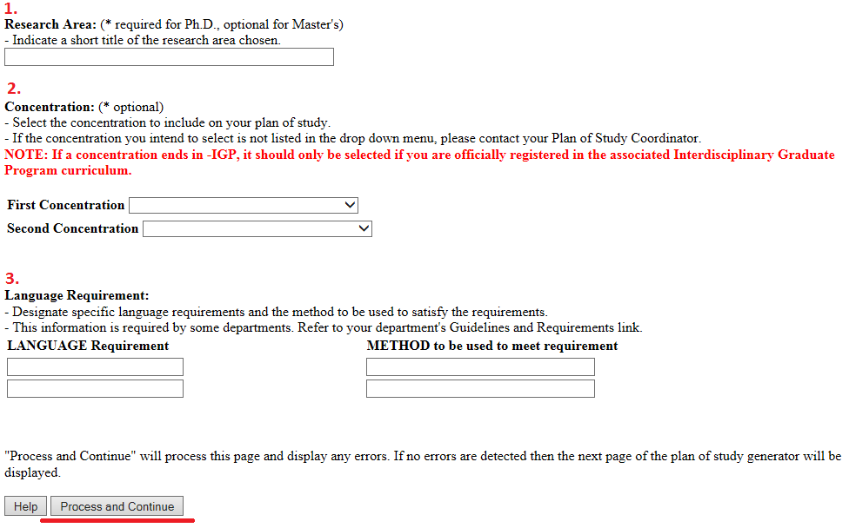
- Click the “Research Area and Concentration” link (the second link shown in Step 7). Enter your research area (if required), select any concentration(s) you are pursuing, and enter the language requirement if one has been established for your program. When all required areas have been completed, click “Process and Continue.”

Introduction to the “Research Area and Concentration” Page
- The “Research Area” is for doctoral and thesis master’s students to enter the tentative focus of their research. Non-thesis students should leave this area blank.
- Per Section I.H. of the University Catalog, requests for concentrations are routinely made through this plan of study process. Graduate students may have up to two concentrations listed on their graduate plan and ultimately their Purdue transcript provided they satisfy all requirements to earn the concentration(s).
- Very few graduate programs still have a language requirement; most students will skip this 3rd area on the page.
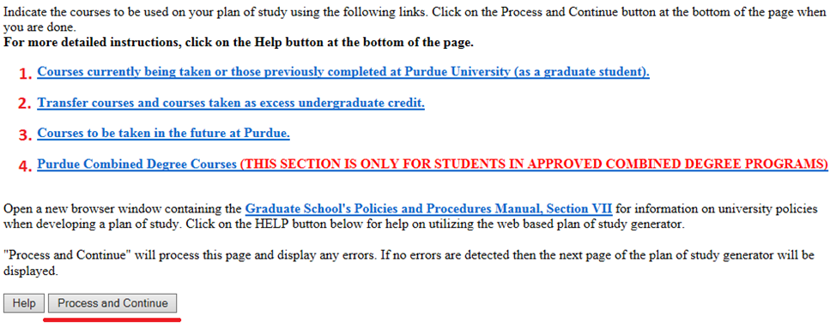
- Click the “Course Work” link (the third link shown in Step 7). Use one or more of the following four links to add the courses you expect to use exclusively for this degree. When all courses have been added, click “Process and Continue” to return to the main screen shown in Step 7. If you are creating a doctoral plan, do not use this “Course Work” area to add courses that were used for a previous awarded master’s degree. Up to 30 credits from an awarded master’s may be used toward the 90+ credits required for a doctoral degree, but approved master’s credits will be listed by your department after you submit your plan.

Four Available Areas for Adding Coursework to a Plan
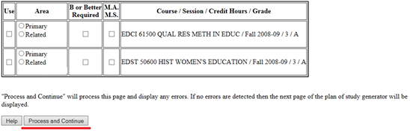
- The “Courses currently being taken or those previously completed…” link will bring up a list of courses for which you have already registered. Check the “Use” box to include this on your plan, designate the “Area,” and check the “B or Better” box if your program requires at least a “B” in the course. When done, select “Process and Continue” to return to the main course page (depicted above). Generally, courses directly required by the degree program should be listed as “Primary” and elective courses should be listed as “Secondary.”
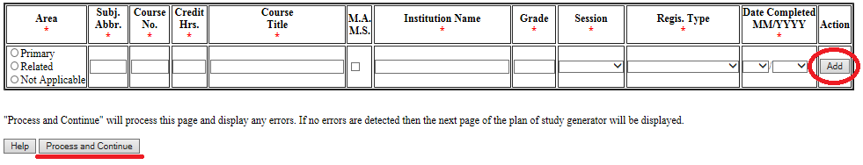
- If you have courses to transfer from another institution to Purdue, select the second “Transfer courses…” link on the main course page. Transfer courses must be “B” or better equivalent, not used for a degree elsewhere, and graduate level. Courses should be added exactly as they appear on the transcript from that institution. When done, select “Process and Continue.”
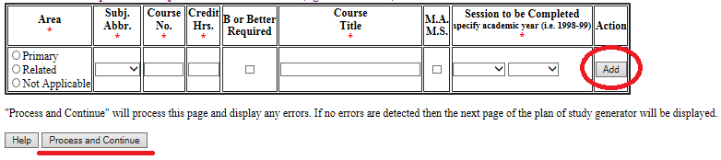
- Enter courses to be taken in the future at Purdue using the third “Courses to be taken in the future…” link on the main course page. Enter the information exactly as it will appear on the Purdue transcript. Once all courses have been added, select “Process and Continue.”
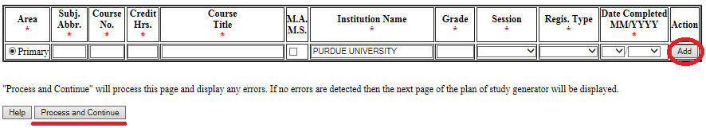
- If you are in an approved combined degree program, use the “Purdue Combined Degree…” link from the main course screen to add the 500-600 level courses to be dual counted between the Purdue undergraduate and graduate degrees. Once these dual courses have been added, click “Process and Continue.”
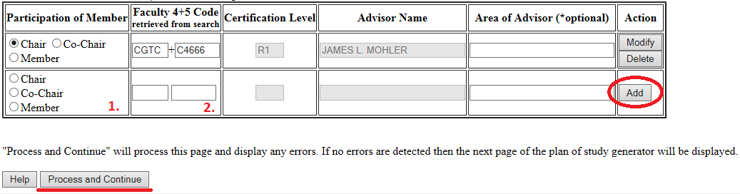
- Click the “Advisory Committee” link (the fourth link shown in Step 7). For each member of your committee, designate the participation level of that member in the first column, enter their department code and faculty ID, and then click “Add.” Most committees require at least three members, but non-thesis option students in certain departments can have as few as one.

Additional Explanation for Adding Committee Members to a Plan
- Committees may have one person designated as “Chair,” or they may have two who are both designated as “Co-Chair.”
- If the department or ID code are not known, use the search faculty search function at the bottom of this page to look up active faculty by department.
- With the exception of non-thesis advisory committees in departments that allow just one member, at least 51% of the committee must hold “R” level faculty certification levels. The “R” and “S” distinctions are noted in the “Certification Level” column above.
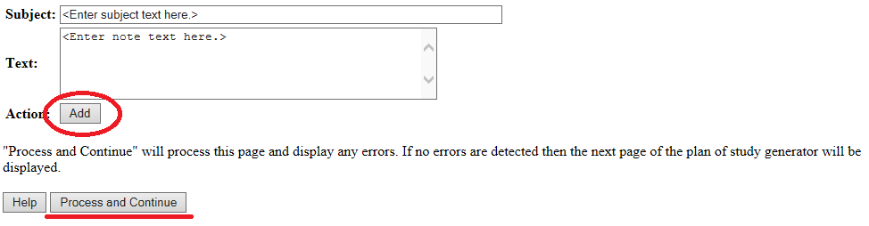
- If you have any notes that you would like to add to this plan (e.g. the number of research credits you expect to take, approved substitutions, or master’s coursework), click the “Comments and Special Notes” link shown in Step 7. Once the note has been added, click “Process and Continue.”
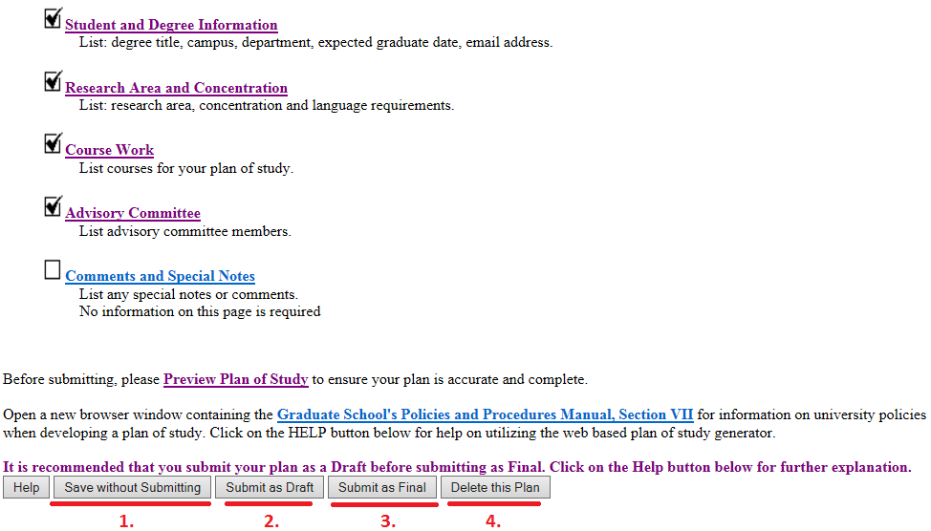
- Once there are “checks” in the boxes to the left of the first four links, the plan is eligible to be submitted for department and Graduate School review.

Explanation of the Gray Buttons on the Home Page for “Saved” or “Draft” Plans
- Click “Save without Submitting” to preserve the information entered for editing at a future time. Plans in “Saved” status may be accessed by either the student or plan of study coordinator.
- Click the “Submit as Draft” button if you would like your advisory committee to see this plan while you still have direct access to make changes.
- If all key components have been included on the plan, click “Submit as Final.” This button will submit the plan for signature. Students must submit their plan as “Final” and receive all department signatures on the form before the start of the session of anticipated graduation. Doctoral students must submit their plan prior to scheduling a preliminary examination for the doctoral degree. For specific dates regarding graduation, see the Graduation Dates and Deadlines Calendar (Graduate School, 2017).
- Selecting “Delete this Plan” will completely remove this plan from the system. Deleted plans cannot be re-accessed. If a new plan is needed, one will need to be initiated from the beginning.

References
Purdue University (2017). University Catalog: Policies & Procedures for Administering Graduate Student
Programs. Retrieved June 2, 2017, from
http://catalog.purdue.edu/content.php?catoid=8&navoid=8285.
Purdue University Graduate School (2017). Graduation Dates & Deadlines. Retrieved June 4, 2017, from
http://www.purdue.edu/gradschool/about/calendar/deadlines.html.

