ART

The Vivacious Presence of Parrots in Dutch Golden Age Painting
An art historian, and African Grey owner, delved into the avian symbolism in Vermeer and the Masters of Genre Painting at the National Gallery of Art.
Allison Meier5 days ago
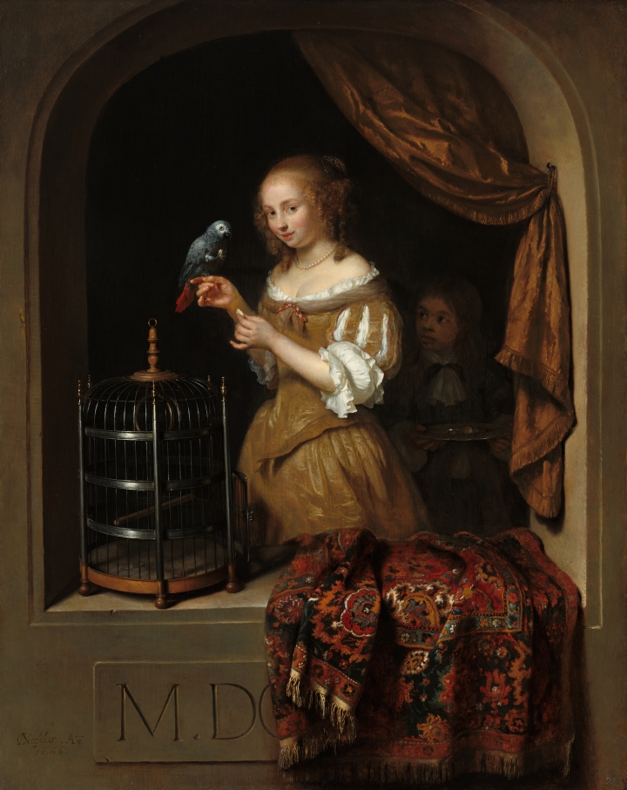Caspar Netscher, “Woman Feeding a Parrot, with a Page” (1666), oil on panel (courtesy National Gallery of Art, Washington, the Lee and Juliet Folger Fund)
Vermeer and the Masters of Genre Painting: Inspiration and Rivalry now at the National Gallery of Art in Washington, DC, includes a 1666 painting by Caspar Netscher of a woman offering a parrot a snack. The work, one of around 70 pieces from the Dutch Golden Age on view, was recently acquired by the museum.
“I walked into the conservation studio, not knowing about the acquisition, and I saw it sitting out there. I said, ‘I own that bird!’” Kristen Gonzalez, the curatorial assistant in the Department of Northern Baroque Paintings, told Hyperallergic. “So I was really interested to look more at Dutch genre paintings. That got me on this research path to look at them from the perspective of an art historian and someone who lives with these creatures.”
Gonzalez has an African Grey parrot, not unlike the one in the 17th-century painting, and that familiarity made her perceive the painted birds as more than solely symbols. In an online feature called “More than Mimicry: The Parrot in Dutch Genre Painting,” she explored the significance of the parrots as metaphors, and their presence as intelligent animal companions. For the latter, she drew on Dr. Irene Pepperberg’s animal cognition studies on African Greys. On November 20, Gonzalez will give a talk at the museum about her research, which is part of a series of features accompanying Vermeer and the Masters of Genre Painting that delve into obscure aspects of the art, like the source of Vermeer’s canvases, or the importance of music in upper-class Dutch life.
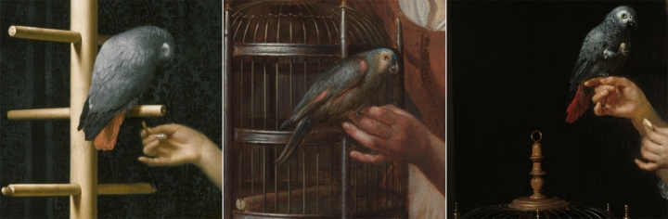Detail of the parrots in Frans van Mieris, “Woman Feeding a Parrot” (1663); Gerrit Dou, “Woman with a Parrot” (1660–65); Caspar Netscher, “A Woman Feeding a Parrot, with a Page” (1666) (© The Leiden Collection and National Gallery of Art)
In the Netscher painting, the parrot commands not only the attention of the woman who feeds it by hand, but also the page who stands in shadow behind her, directing his gaze at the bird. The woman’s confidence, looking directly at the viewer, is reinforced by her relationship to the animal.
“A number of these artists may have actually lived with a parrot and were able to paint the parrot so carefully so that you get not just a realistic likeness, but a sense of the personality,” Gonzalez noted.
On view in Vermeer and the Masters of Genre Painting are two loans from the Leiden Collection that portray women with parrots, one by Gerrit Dou, and another by his pupil, Frans van Mieris. Dou’s 1660–65 work shows a woman bringing a blue-front Amazon parrot out of its cage, the gesture referencing a cautious assertion of her sexual freedom. Meanwhile, van Mieris’s 1663 painting, of his wife feeding an African Grey, is a more tender scene of married life. The thimble on her finger suggests she was just interrupted in her sewing by the attention-demanding parrot, and is now proffering a treat from her hand. The bird arches its feathery neck in response, awaiting a scratch from its owner.
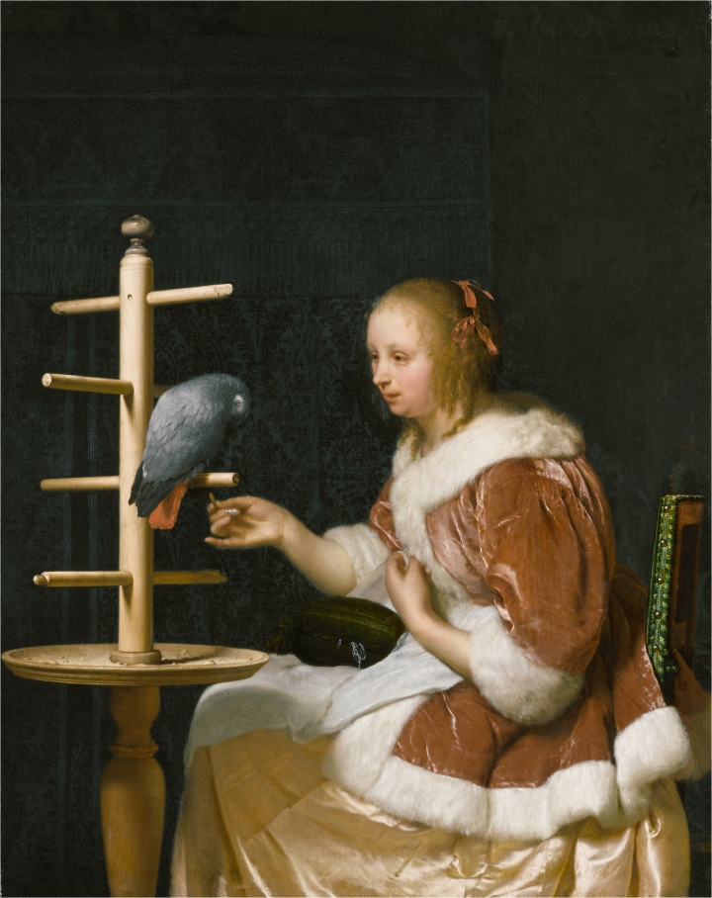Frans van Mieris, “Woman Feeding a Parrot” (1663), oil on panel (© The Leiden Collection, New York)
“In a lot of ways it’s an opportunity for a look inside domestic interiors that we’ve never been afforded,” Gonzalez stated. “I think it’s a great way to look at the private life of these people living so fortunately in the Dutch Golden Age.” Indeed, owning a parrot was a marker of status, as the rare avians conveyed worldliness and wealth. Imported from Africa and Asia (before protections on such poaching), birds joined the pearl necklaces, Persian rugs, fur coats, and other markers of prestige in these portraits.
While flamboyantly colored and smart, parrots are also mischievous, noisy, animated, and messy. They throw around their food, they lose feathers. And the clean cages always present in these paintings are not realistic. Yet the connection between the people and the parrots is convincingly portrayed. Parrots are not docile, not completely tamed, and their depictions in these paintings cannot be perceived simply as static symbols.
“I think the Dutch got that, and that’s why you see them not only included because they’re beautiful, but because they were part of the family,” Gonzalez said. “The Dutch genre painters were the first ones to display them that way.”
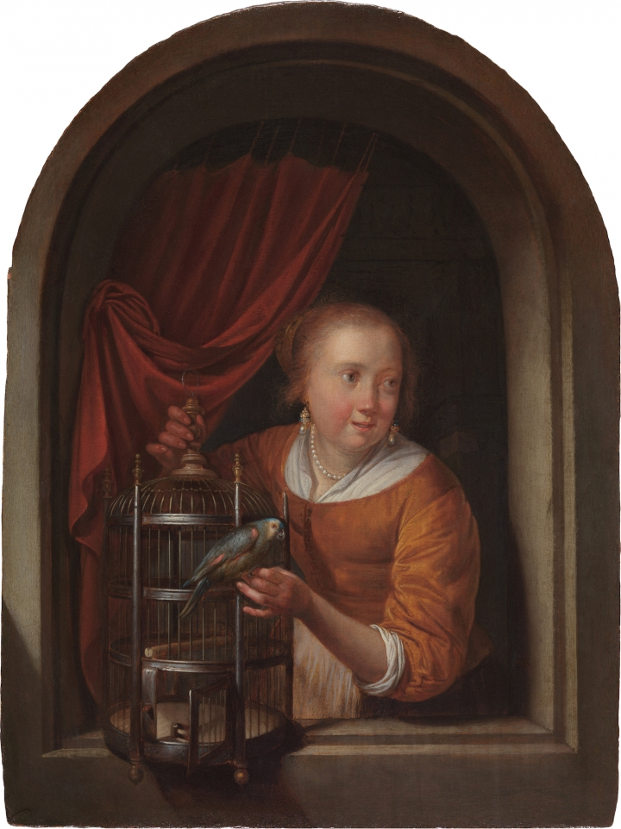Gerrit Dou, “Woman with a Parrot” (1660-65), oil on panel (© The Leiden Collection, New York)
Vermeer and the Masters of Genre Painting: Inspiration and Rivalry continues through January 21, 2018 at the National Gallery of Art (6th and Constitution Avenue NW, Washington, DC).

