NEWS

Evidence Mounts that Rembrandt Used Optics to Paint Self-Portraits
Claire VoonAugust 5, 2016
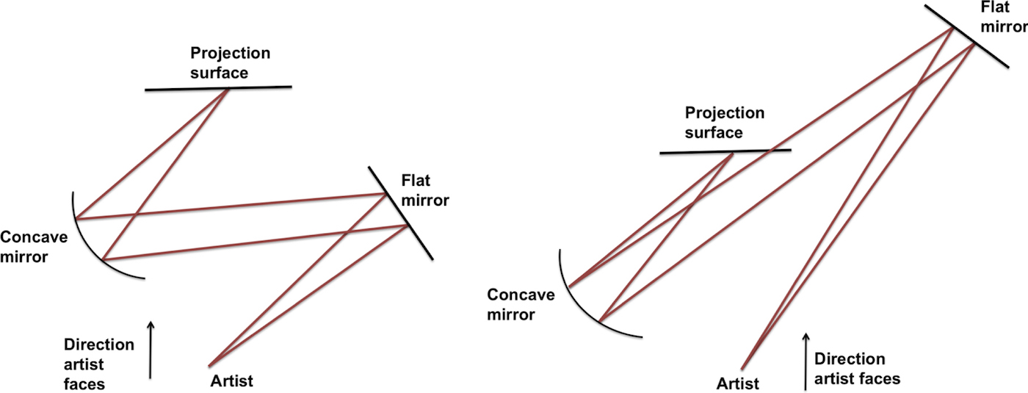Left: arrangement for a projection of the face for a self-portrait; Right: set-up for a projection for a portrait including more of the body, where the image is smaller (all images courtesy Francis O’Neill et al 2016 J.Opt 18 080401) (click to enlarge)
A new study of Rembrandt’s self-portraits provides more evidence to theories that the 17th-century artist, among other Old Master painters, used optics to produce his remarkably accurate works. Researchers Francis O’Neill and Sofia Palazzo Corner recently published their paper in the Journal of Opticsthat explains how various setups of flat and concave mirrors, all widely available during Rembrandt’s time, may have created projections the artist could precisely trace.
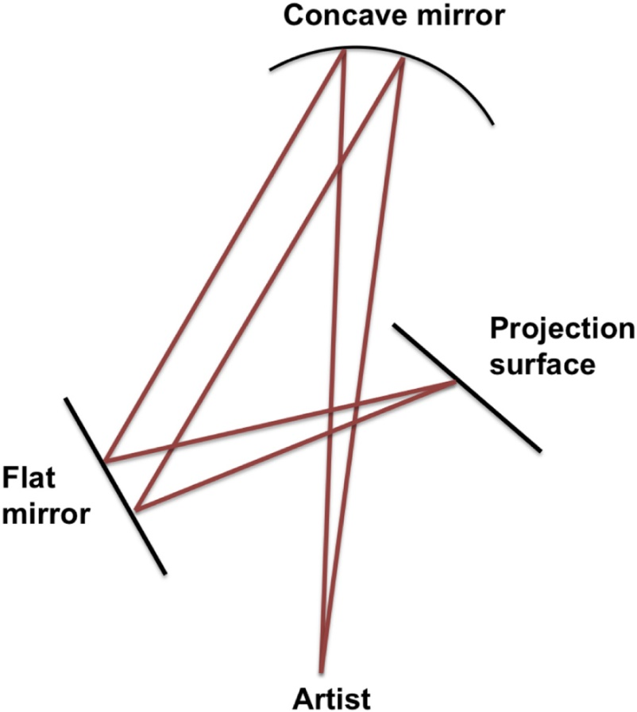Diagram of set up for life-size self-portrait projections, where the artist would stand at 2× the focal length of the concave mirror, which is equal to the sum of the distances between the concave mirror and flat mirror, and the flat mirror and projection surface. A clear, life-size projection was achieved using a 10 cm diameter mirror with focal length 100 cm (click to enlarge)
The pair’s research builds on David Hockney and physicist Charles M. Falco’s controversial hypothesis of 2001, which claimed that artists since the Renaissance used optical devices from curved mirrors to the camera obscura to achieve realistic images. O’Neill, himself a painter and art teacher, spent the last decade examining Rembrandt’s paintings; with Corner, an independent physicist, he fiddled with mirror arrangements to identify the positions and distances that would concentrate light in a way to produce projected images of himself similar in scale to Rembrandt’s self-portraits. In the diagrams, light reflects off the mirrors in a zigzag pattern, landing on a projection surface that had to stand within arms-length of the artist. Rembrandt’s choice of material, the researchers say, suggests that he did employ such setups with optics.
“The earliest of Rembrandt’s self-portraits are striking for the level of detail accomplished in such small images,” the pair writes. “A number of these smaller self-portraits are etched onto copper, a surface upon which projections can be seen extremely clearly. Two early painted self-portraits are also made on copper—an unusual choice of surface for a painting, but perhaps telling of an artist working from a projection.”
The researchers examined several other common aspects in the Dutch artist’s works such as his off-center gaze, which they say may suggest he was facing a projection surface off to the side rather than looking directly at his reflection in a flat mirror. Projections would also likely enable him to paint more lively poses — such as of himself laughing — as he would be able to freeze his entire facial expression while tracing the projected image, rather than moving slightly as he worked between mirror and canvas. Rembrandt’s use of chiaroscuro, the researchers say, may also have been a byproduct of his projections, as the technique’s necessary, precise lighting conditions would have created “an image with strong light-and-dark contrast.”
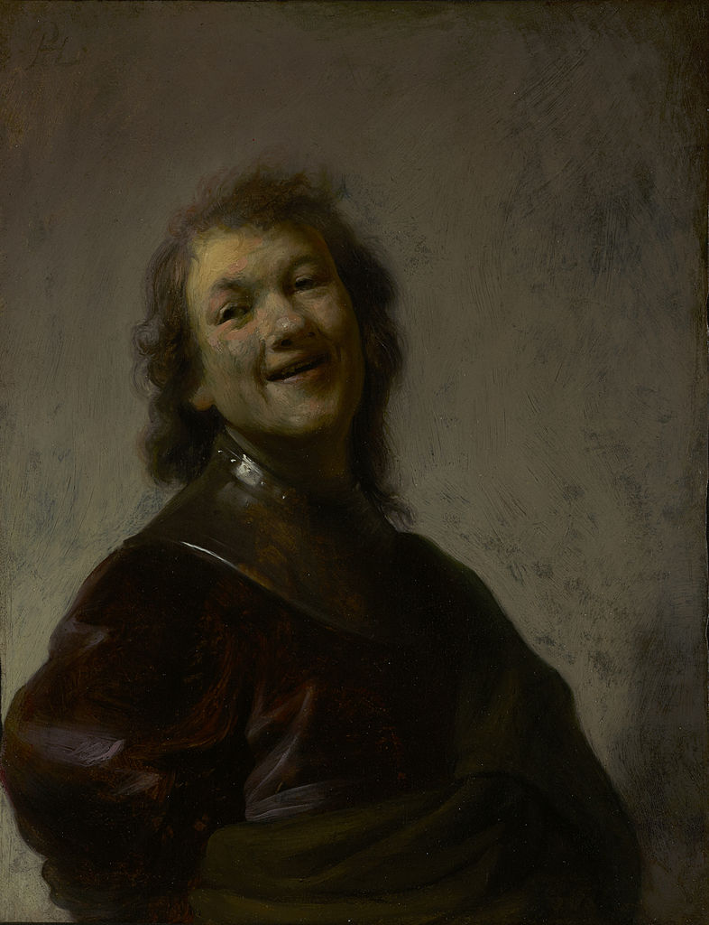Rembrandt, “Rembrandt Laughing’ (1652) (image via Wikipedia)
One of the paper’s particularly interesting propositions is that Rembrandt’s portraits increased in size overtime as he was increasingly able and more willing to invest in larger concave mirrors with greater focal lengths.
“His ability to maintain the realism and detail of his smaller, earlier images as well as the sheer scale of his later self-portraits, is what remains so striking,” the authors write. “In a simple, flat-mirror reflection, the distance from artist to mirror required to achieve visibility of the torso, let alone the whole body, would leave the details of the face and hands difficult to see, as the reflected image would necessarily be formed at a distance that precludes such close scrutiny. The further the reflected image from the artist, the greater it appears reduced in size, and yet, in his late works, Rembrandt consistently paints himself at a minimum of life size.
“The use of concave mirror projections enables the artist to be close to the projection of a life size composition, and hence able to observe the details of his features, albeit in the soft focus of the projected image.”
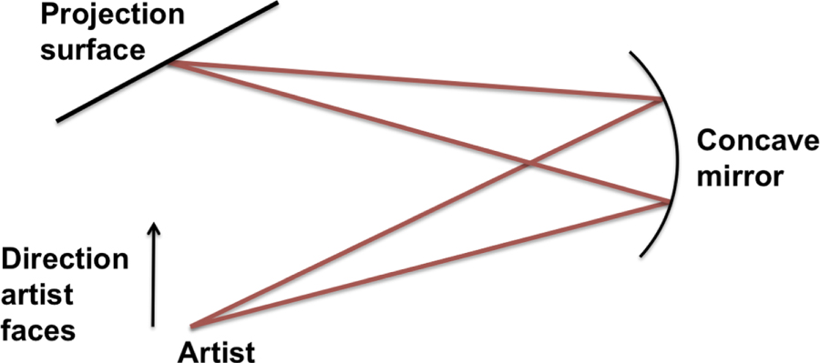Diagram of set up for a self-portrait projection using a single concave mirror, which allows for the projection of profile self-portraits. This method may have been used by old masters such as Durer, but not by Rembrandt
According to the New York Times, Falco apparently praised O’Neill for his work; optics expert David G. Stork, however, who staunchly rejects the Hockney–Falco thesis, remains unconvinced, stating that no historical documentation exists as proof that optics aided Old Masters.
“People have accused me of being jealous, or trying to discredit Rembrandt, but that’s not at all what I’m trying to do,” O’Neill told the Times. “If you gave a projection to someone on the street and told them to make a masterpiece, they would never give you a Rembrandt.”
Just as scientists at the time used lenses to better understand previously unseen natural phenomena, the researchers argue, it would follow that artists, too, likely would have taken advantage of the technology to view their own position within the world.

