Employees assigned the Positive Duration time entry profile are required to enter the number of hours they worked on each work day.Timesheets must be submitted after you have worked your final day or shift before the end of each week. After submitting your timesheet, it flows to your supervisor for approval. For information regarding pay periods and calendars see the Payroll and Tax Services website.

Contents
Policies & Concepts 1
Employee Responsibilities 1
Supervisor Responsibilities 1
Resources 2
Overtime 2
Holidays, Moving Holidays, Holiday Emergency Work 2
Timekeeping in SuccessFactors 2
Accessing SuccessFactors 2
Accessing the Timesheet 3
Entering Working Time 4
Entering Call Back Time 5
Saving and Submitting 6
Amending a Timesheet After Submitting 7

Policies & Concepts

Employee Responsibilities
- Accurately recording time worked
- Selecting the appropriate job when recording time (if employee records time for multiple jobs)
- Proactively working with their supervisor to resolve issues as needed
- Ensuring that their time is recorded completely and accurately and submitted for supervisor approval following their final work day of each week.
- Remember: The time entered into the system will be considered true and accurate as of the end of an employee’s pay period. It is the employee’s responsibility to review their time often (at least at the end of each shift and at the end of the pay period) to make sure the recorded hours are true and correct; and to review and confirm the accuracy of any changes that a supervisor makes to time entries.

Supervisor Responsibilities
- Proactively working with their employees to resolve issues as needed
- Reviewing/approving all time sheets for all of their employees by 12:00pm on the Tuesday following the end of each pay period
- Proactively working with their business office to update employee work schedules and report costing exceptions for their employees’ time worked
- Remember: The time entered into the system will be considered true and accurate as of the end of an employee’s pay period. It is the employee’s responsibility to review their time often (at least at the end of each shift and at the end of the pay period) to make sure the recorded hours are true and correct; and to review and confirm the accuracy of any changes that a supervisor makes to time entries.

Resources
The most current versions of all timekeeping resources for Employees and Supervisors can be found on the Payroll’s SuccessFactors Timekeeping website. https://www.purdue.edu/timehelp

Overtime
SuccessFactors adheres to the University policy regarding overtime. When a full time employee records over 40 hours in a workweek, the time will be designated as overtime. “Hours worked” in a work week will consist only of hours actually worked. (Exception: Worker’s Compensation, University Holidays).

Overtime for employees with multiple positions will be charged to each position based on the ratio of hours worked across the employee’s positions for that week.

Holidays, Moving Holidays, Holiday Emergency Work
Holidays
Holiday premiums are auto-calculated when time is recorded.

Moving Holidays
Moving Holidays takes place within SuccessFactors Time Off tile. Individuals whose work schedule does not include a given University Holiday can use the time off feature within SuccessFactors to request Holiday on any day during the week (Sunday through Saturday) of the holiday. Exception: Police and Fire may request Holiday leave at any time throughout the year.

Unplanned Work on a Holiday or During an Emergency
Per University policy, when an employee works during an emergency or unscheduled holiday work, they qualify for time to be paid at time and a half. In the event that essential personnel are required to work during an emergency or unscheduled on a holiday, the employee or their supervisor must enter the time on the employee’s timesheet using time type Campus Service Disruption.

Timekeeping in SuccessFactors

Accessing SuccessFactors
Visit OneCampus and select Employee Launchpad. | https://one.purdue.edu/
Log in using Purdue Career Account ID and BoilerKey passcode.  For assistance using or setting up BoilerKey, please contact ITaP at itap@purdue.edu or 765-494-4000. | 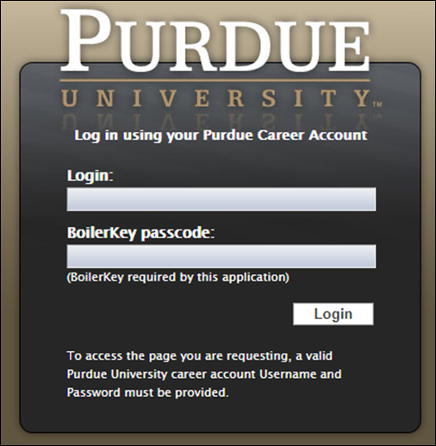

Accessing the Timesheet
If you have multiple positions for which you record time,  In the upper right corner of the screen, select the position for which you would like to record time from the menu next to your name. | 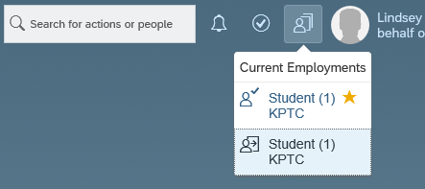
To access the employee timesheet, click the Time Sheet tile within the Employee Central homepage. | 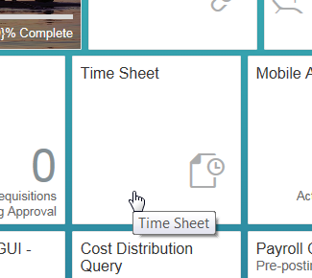
The current week’s timesheet opens and the current day is displayed in red font. | 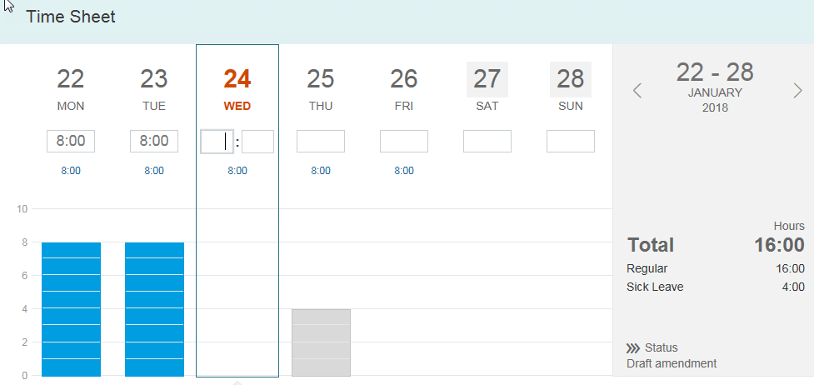
Navigate to the desired timesheet by clicking the back (left) arrow or the next (right) arrow on either side of the date range. | 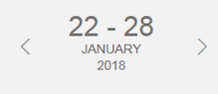

Entering Working Time
Select the day on which time is to be entered. |  | 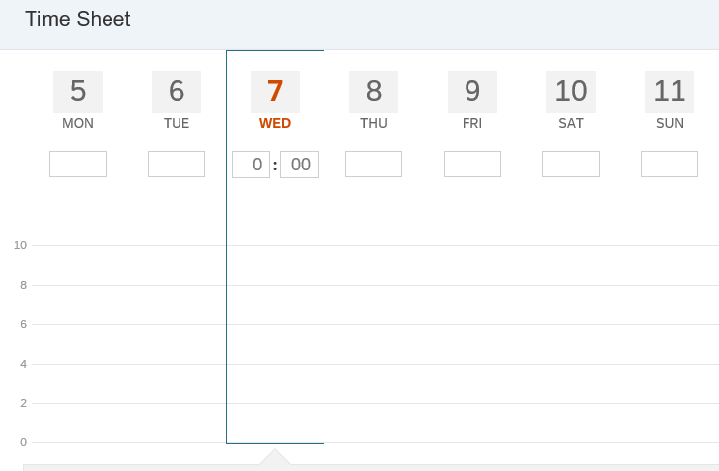
There are 2 methods for entering time. Each method is shown below.
- Enter number of hours worked within numerical entry field. |  | 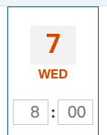
- Click the point on the graph that corresponds with the number of hours worked that day. |  | 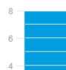
Total reflects time worked, such as regular time and overtime.  Note: Overtime will only appear once the total time worked entered for the week exceeds the overtime threshold (typically, 40 hours).  The Total does not reflect non-worked time such as leaves and holidays.  A breakdown of all pay type hours is found beneath the Total worked time. |  | 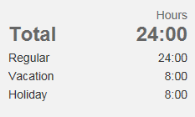
Click Save Draft.  (Use the Submit button after your final shift of each week to submit the Time Sheets for supervisor approval. See the Saving and Submitting section for more details.) |  | 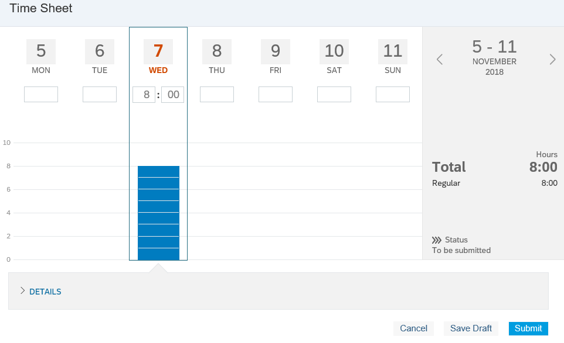

Entering Call Back Time
Select the day on which Call Back time is to be added.  Click DETAILS to expand the section below.  Click + Add On-Call Time  Note: Despite the presence of the +Add Absence button within the Details drop-down, all time off and leaves requests must be entered through the Time Off tile within the Employee Central Homepage.  Instructions for submitting Time Off requests can be found on the SuccessFactors Training page. | 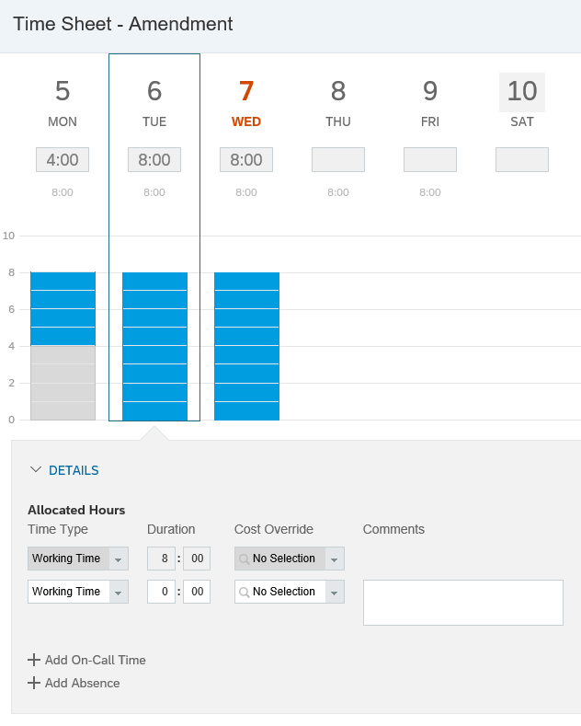
In the Duration field, enter 2:00  (In alignment with Purdue Call Back policy) | 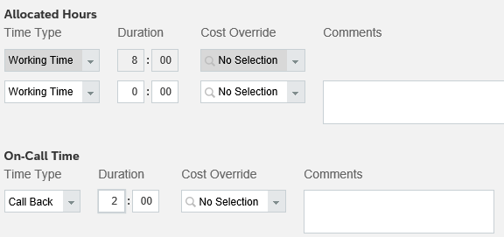
Enter the amount of hours worked during the Call Back instance within the Allocated Hours section  In the open Working Time Duration field, enter the number of hours worked during period for with you were Called Back.  In the example shown, the individual worked their 8 hour shift and then was called back and required to work 4 additional hours. Total Working Time for the day was 12 hours.  Click Save Draft.  (Use the Submit button after your final shift of each week to submit the Time Sheets for supervisor approval. See the Saving and Submitting section for more details.) | 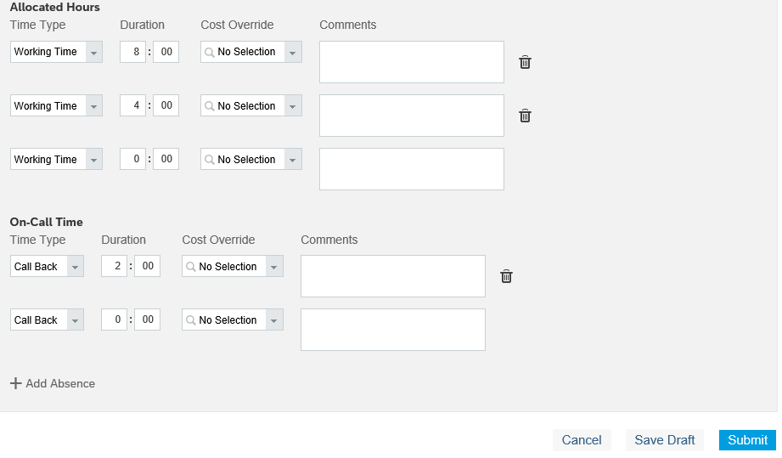

Saving and Submitting
Time Sheets in SuccessFactors are weekly; pay is distributed bi-weekly.
For details on pay periods and pay dates, see the Payroll and Tax Services website.
If not yet ready to submit the timesheet, click Save Draft. If ready to submit for approval, click Submit. |  | 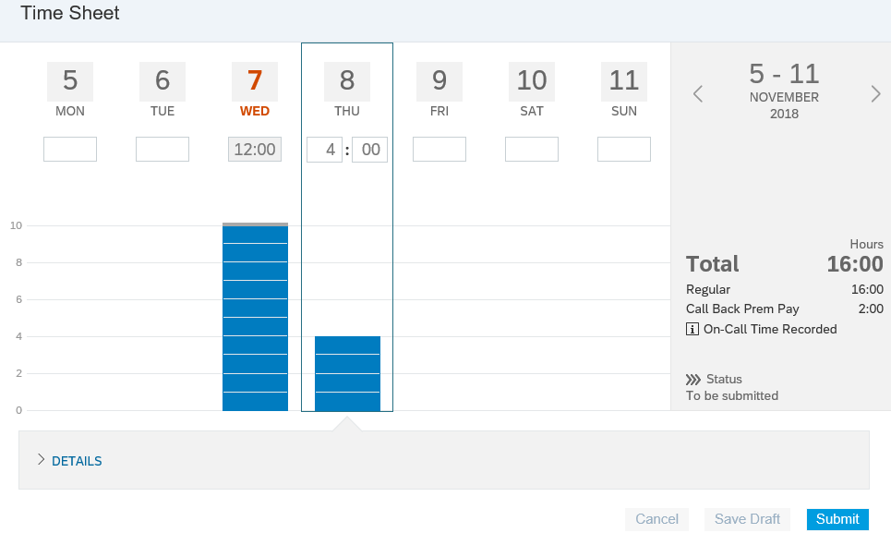
Review the dialog box and enter a comment if appropriate. Then click Submit. |  | 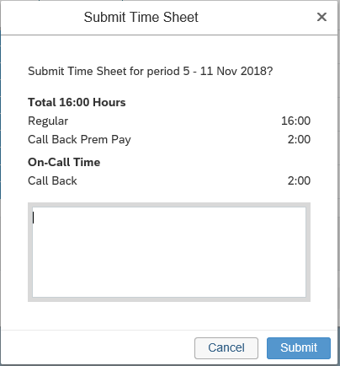
Status will change to “To be approved.”  The timesheet flows to the supervisor for approval. |  | 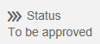

Amending a Timesheet After Submitting
Employees are able to edit timesheets (even if already approved) that are within the current or two previous pay periods. To edit timesheets further in the past, contact your supervisor. After a timesheet is edited, it flows to the supervisor for approval. For additional information, see the Timesheet Corrections process.
If status is still “To be approved,” click Withdraw. |  | 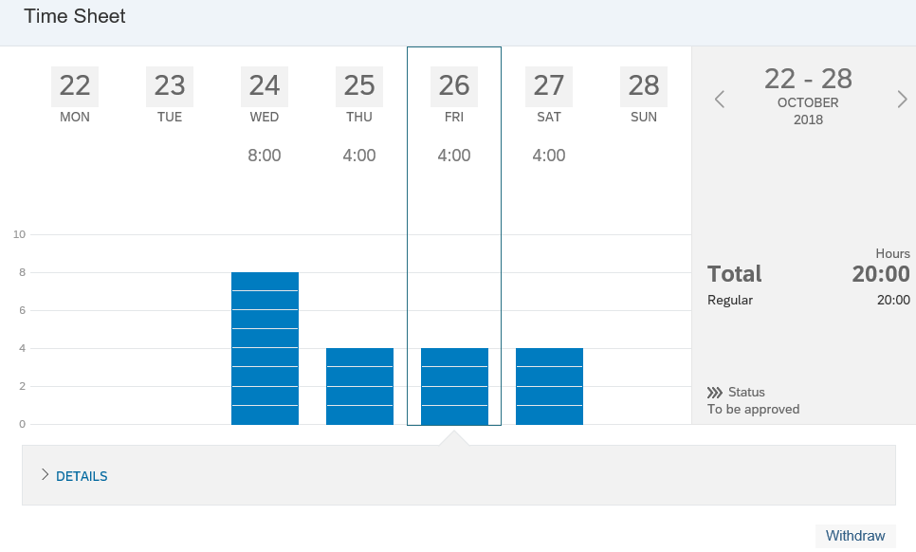
If status is “Approved,” click Make Amendment. Status will change to “Draft amendment.” |  | 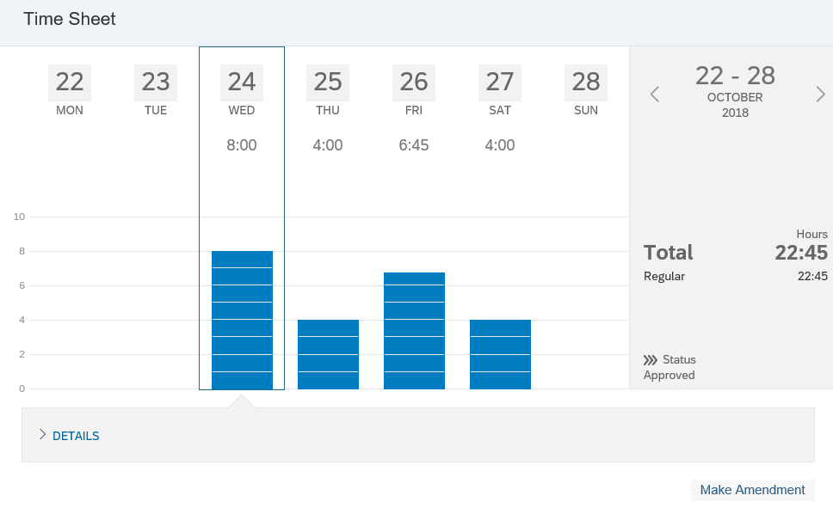
Make desired changes to the timesheet.  Click Submit.  Note: Button will read “Resubmit” if it was previously approved. |  | 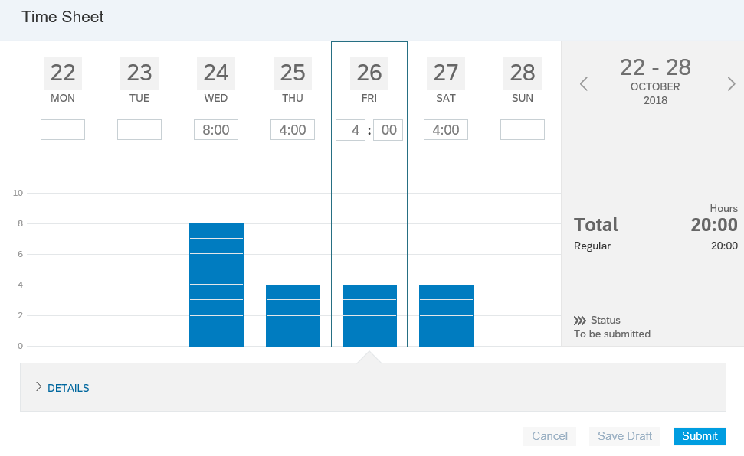
Status will change to “Amendment to be approved.” |  | 